1. **Create/download a file from data source into your local**
2. **gunzip the file using gzip command**

**3)Copy gzip file to your created bucket:**

cp C:/Users/Admin/Downloads/2009.gz gs://gspanntst

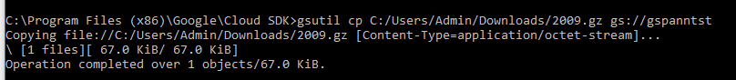

**4)Create a table for loading .gz file**

mk -t gspann_tst.gz_compress Year:string,Month:string,DayofMonth:string,DayOfWeek:string,DepTime:string,CRSDepTime:string,ArrTime:string,CRSArrTime:string,UniqueCarrier:string,FlightNum:string,TailNum:string,ActualElapsedTime:string,CRSElapsedTime:string,AirTime:string,ArrDelay:string,DepDelay:string,Origin:string,Dest:string,Distance:string,TaxiIn:string,TaxiOut:string,Cancelled:string,CancellationCode:string,Diverted:string,CarrierDelay:string,WeatherDelay:string,NASDelay:string,SecurityDelay:string,LateAircraftDelay:string

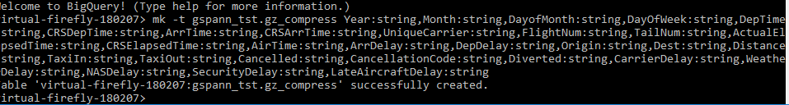

**5)Load created table:**

load virtual-firefly-180207:gspann_tst.gz_compress gs://gspanntst/C:/Users/Admin/Downloads/2009.gz



**6)Test the load data:**

